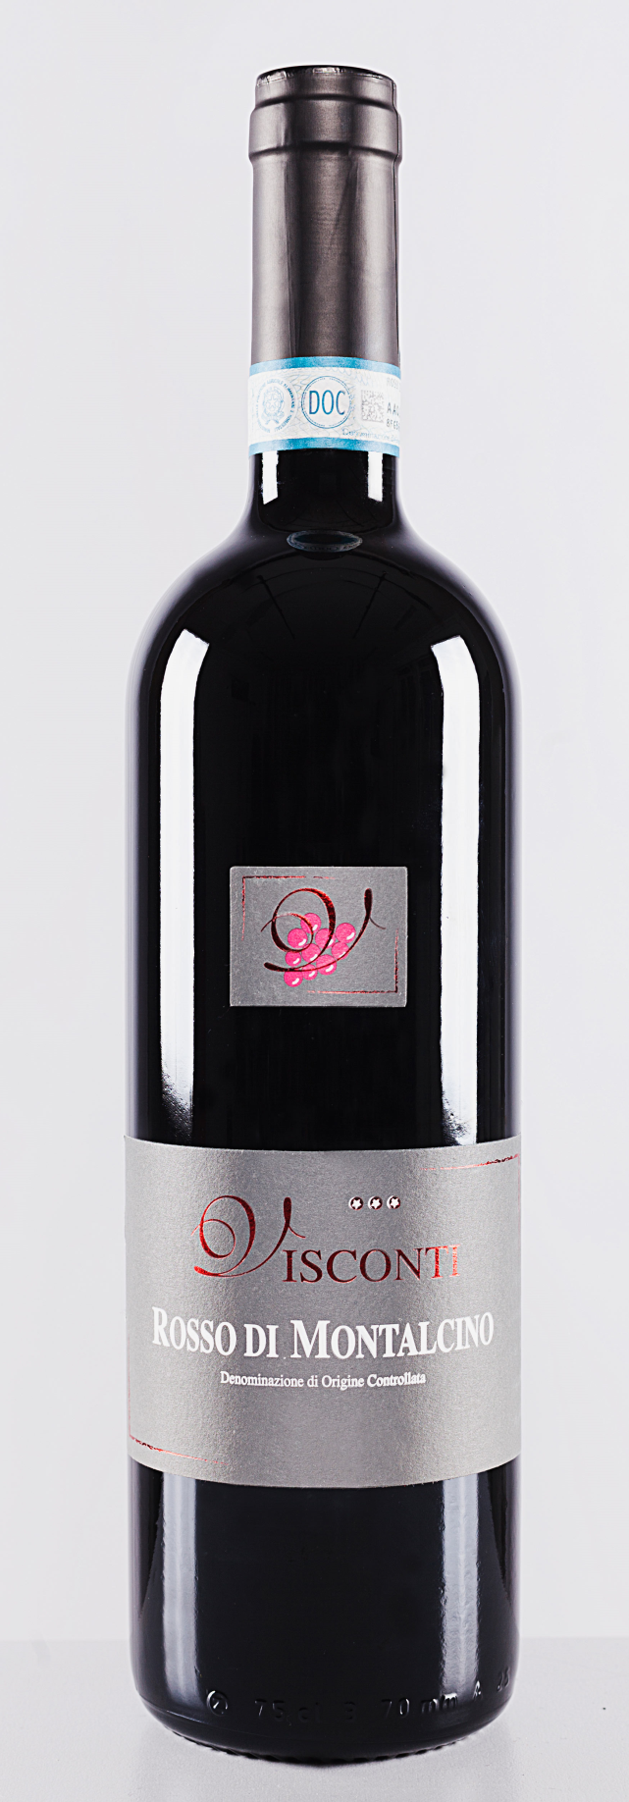
ROSSO DI MONTALCINO DOC
Production area | Castelnuovo dell'Abate - 365 m above the sea level.
Soil charateristic | Limestone rich in stone marl
Grapes | 100% Sangiovese
Planting density | 5.500 plants/Ha
Vineyard b. sistem: | Spur Pruned
Age of vineyards | about 15-20 years older.
Alcohol | 14,50%
Vinification | After the hand selection and harvesting of the grapes, two days of cold maceration followed by alcoholic fermentation at controlled temperature in stainless still tanks, followed by malolactic fermentation.
Aging | 14 months in french tonneaux from 5 hl
Bottle-aging | 4 months
Colour |  | Bright ruby red with violet reflections.
Bouquet |  | Intense, fresh, fruity with typical variety of violet, cherry, plum
Taste |  | Soft tannins, good acidity, Gentle, soft with intense lenght
Pair with |  | meat, game and cheese

